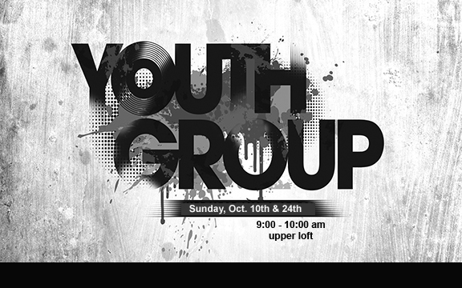

Youth Group Meeting
Sunday, December 5, 2021
Sunday, December 12, 2021
9 - 10 am
Upper Loft

